STEP 1: RESILIENCY TRAINING
This resiliency training includes both proactive and reactive approaches to stress management, health and wellness. Practical “reset” tools for balance and stability provide a holistic approach encompassing mental, physical, spiritual and social domains. The cornerstones of the didactic training emphasize the Mental Health Continuum and Big 4+ (Attention Control, Goal Setting, Progressive Muscular Relaxation, Self Talk, Box Breathing and Visualization).

OVERVIEW:
STRIVE was developed based on the Canadian Armed Forces Road to Mental Readiness Program and reinforced with experiential learning through practical simulation training. This integration prepares health care providers to thrive in challenging and stressful clinical environments.
STEP 2: PRACTICAL SIMULATIONS
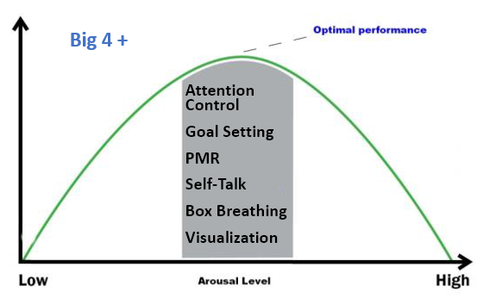
This resiliency training is reinforced through challenging simulations. A variety of modalities can be utilized including: role playing scenarios, actor lead scenarios, skill based training and high-fidelity medical simulation.

STEP 3: EFFECTIVE DEBRIEFING
The simulations are followed by debriefing using an experiential learning framework. Facilitators encourage participants to reflect on their experience, evaluate application of resiliency skills and reinforce strategies to
improve future performance.

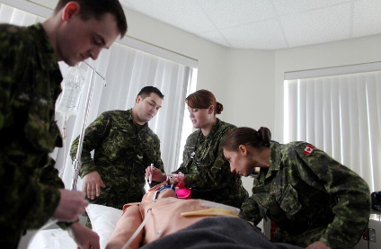
STEP 4: REFLECTIVE PRACTICE
Developing an approach to maintaining health and wellness while managing both day to day and acute stress requires regular reinforcement of resiliency skills. All participants are encouraged to apply these skills frequently and to conduct regular personal checks to enhance mental health outcomes.

