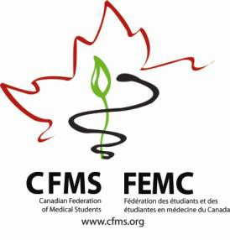

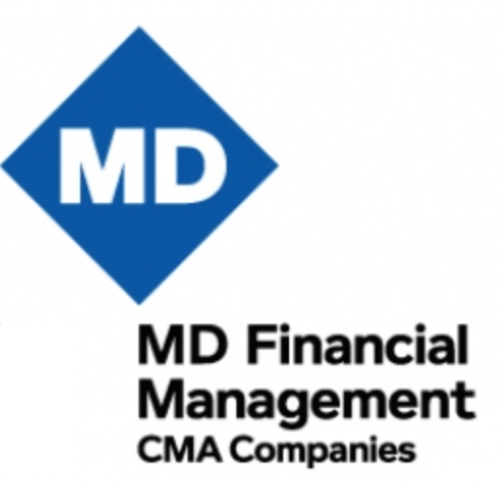
CFMS Spring General Meeting
Hôtel Bonaventure
900 rue de la Gauchetière O
Montreal, QC

Thursday, April 14, 2016
CFMS Business Meeting
18:00 – 19:30 | FMEQ-CFMS Executive Meeting
19:30 – 21:00 | CFMS Executive Meeting  CFMS Executive Only  St-Pierre
20:00 – 23:00 | CFMS Representatives Meeting Representatives Only 20:00 – 23:00  Fontaine C  Click here for Reps Agenda | Global Health Program  20:00 – 23:00  Fontaine B  Click here for GHP Agenda | Presidents’ Roundtable  Presidents Only 20:00 – 23:00  Fontaine A  Click here for PRT Agenda

Friday, April 15, 2016
CFMS Business Meeting
Outremont
Independent Breakfast, CCME Registration (Mezzanine, Fairmont Queen Elizabeth)
7:00 – 9:45 | CFMS Representatives Meeting  Representatives Only 8:00 – 9:00  Outremont  Click here for Reps Agenda | Global Health  Program  7:00 – 10:00  Verdun  Click here for  GHP Agenda | Presidents’ Roundtable  Presidents Only  7:00 – 9:00  Lachine  Click here for PRT Agenda
8:30 – 9:00 | CFMS Registration
9:00 – 9:15 | Welcome & Introduction  Chair, Emily Hodgson
9:15- 9:45 | External Student Groups Panel  FMEQ, OMSA, CFPC, AMSCAR  Moderated by Emily Macphail
9:45 – 10:00 | Break

10:00 – 10:30 | President’s Report  Anthea Lafreniere
10:30 – 11:00 | Small Working Group #1  Yousif Atwan
11:05 – 11:35 | Small Working Group #2  Yousif Atwan
11:40 – 12:10 | Small Working Group #3  Yousif Atwan
12:15 – 13:15 | Lunch
13:15 – 13:55 | Keynote Address  Mr. James Hughes
13:55 – 14:10 | AFMC Immunization Group  Nebras Warsi, Anthony Maher & AFMC Delegates
14:10 – 14:30 | Education Committee Update  CFMS Education Committee
14:30 – 14:45 | Break
14:45– 15:00 | AFMC President & CEO  Dr. Geneviève Moineau
15:00 – 15:30 | Finance Report  Franco Rizzuti  In Camera
15:30 - 16:15 | Advocacy Tracker & Government Affairs Update  Jessica Harris
16:15 – 16:30 | Overflow
16:30 – 17:00 | Wellness Event  Art Therapy  Outremont | MDFM Leadership Awards Cocktail  Leadership Award recipients & Executive only  Pointe-aux-Trembles | Global Health Program  16:30-18:30  Westmount  Click here for GHP Agenda | MCC Focus Group  17:00-18:00  Invited guests only  Resto-Bar Le Belvédère
17:00 – 17:30 | Resolutions Committee Meeting  Res. Committee  Outremont
19:00 – 21:30 | Dinner – Wienstein & Gavino’s  1434 Rue Crescent, Montréal, QC H3G 2B6
21:30 –24:00 | CFMS Social – Sir Winston Churchill Pub Complex  1459 Rue Crescent, Montréal, QC H3G 2B2

Saturday, April 16, 2016
CFMS Business Meeting
Outremont
Independent Breakfast
6:45 – 7:30 | Wellness Event (Optional)  Run up to Mount Royal Observatory  Meet in lobby of Best Western Montreal Plus Downtown (1240 Drummond)
8:00 - 8:30 | National Wellness Survey & Wellness Challenge  Brandon Maser, Marie-Pier Bastrash
8:30 - 8:50 | AGM 2016 Edmonton  Edmonton Representatives
8:50 – 9:10 | Website Launch  Carl White Ulysse, Kevan Lu
9:10 – 9:55 | Education Panel: Residency Entry Disciplines  Dr. Tom McLaughlin, President, Resident Doctors of Canada  Dr. Jay Rosenfield, Vice-Dean UGME, University of Toronto  Dr. Nick Busing, FMEC-PG Project Lead, AFMC  Dr. Craig Campbell, Director of Professional Development, Royal College  Facilitated by Nebras Warsi
9:55 – 10:15 | CMA Medical Professionalism Initiative  Jenny Buckley, Emily Gruenwoldt
10:15 – 10:45 | Break |  | Match Book Photoshoot
10:45 – 12:00 | Members Resolutions Session 1  Chair, Emily Hodgson
12:00 – 12:45 | Lunch | MDMF Awards Presentation |  | Match Book Photoshoot
12:45 – 14:15 | Election of CFMS President  Dr. Bryce Durafourt
14:15 – 14:30 | Break
14:30 – 17:00 | Members Resolutions Session 2  Chair, Emily Hodgson
17:00 – 17:30 | Closing, Informal Q & A and Meeting Evaluation  CFMS Executive Committee
17:30 – 18:00 | Overflow
Evening | Independent or Faculty-Specific Dinner
22:00 – 24:00 | CFMS Social – Le Confessional  431 Rue McGill, Montréal, QC H2Y 2G5

Sunday, April 17, 2016
(Optional)
Canadian Conference on Medical Education
Fairmont Queen Elizabeth & Hôtel Bonaventure Montreal
6:00 – 7:00 | CCME Yoga & Group Running Groups  Fairmont Queen Elizabeth  Sign up in advance: Mezzanine level of Fairmont
8:00 – 9:30 | Education Research Symposium  Le Grand Salon  Fairmont Queen Elizabeth | CaRMS Forum  8:00-10:00  Westmount  Hôtel Bonaventure
10:00 – 11:30 | Educational Innovation: Improving Quality of Care in Curricula  Le Grand Salon  Fairmont Queen Elizabeth
12:00 – 13:00 | MCC Executive Lunch  11:30-13:00  CFMS Executive only | AFMC Lunch & Learn(er) Forum  Sainte-Françoise Ballroom  Fairmont Queen Elizabeth

Monday, April 18, 2016
(Optional)
Canadian Conference on Medical Education
Fairmont Queen Elizabeth & Hôtel Bonaventure Montreal
6:00 – 7:00 | CCME Yoga & Group Running Groups  Fairmont Queen Elizabeth  Sign up in advance: Mezzanine level of Fairmont
8:30 – 9:30 | Plenary Session: Balancing Self and Professional Responsibilities  Le Grand Salon  Fairmont Queen Elizabeth
15:30 – 17:00 | AFMC Hot Topic  Le Grand Salon & Marquette  Fairmont Queen Elizabeth

Note: this agenda is subject to change

