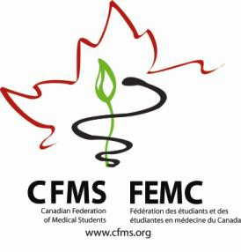
CFMS Spring General Meeting
Global Health Agenda
Fairmont Hotel Vancouver
900 West Georgia Street
Vancouver, BC

Thursday, April 23, 2015
Global Health Program
Waddington Room
19:00 – 20:30 | CFMS Executive Meeting  CFMS Executive Only
20:00 – 20:45 | Welcome and Introductions
20:45 – 21:00 | Vice-President’s Report
21:00 – 21:15 | Break
21:15 – 22:45 | National Officer Reports  (15 minutes each)  NOGHE  NORSH  NOP  NEO  NOHRP  NAHL
22:45 - 23:00 | Overflow

Friday, April 24, 2015
CFMS Business Meeting
Pacific Ballroom
Independent Breakfast and CCME Registration
8:30 – 9:00 | CFMS Registration
8:00 – 8:15 | Introductions cntd.
8:15 – 8:30 | Transgender Health Policy Paper
8:30 – 8:45 | Antimicrobial Stewardship Policy Paper
8:45 – 9:00 | Humans of Pharmacare Launch
9:00 – 9:15 | Break
9:15 – 9:30 | Partner’s in Health Competition
9:30 – 9:45 | Access our Medicines
9:45 – 10:00 | IFMSA Discussion
10:00 – 16:30 | Join CFMS Business Meeting
16:30 – 17:30 | Global Health Brainstorming
17:30 – 18:00 | Global Health Core Competencies  Golden Gao
18:00 – 18:30 | NextGenU.org  Dr. Frank
18:30 – onwards | Q & A and Wrap-Up

